**Overview**

A College Hub **Bulletin Board** System is designed to streamline communication, resource management, and announcements within a college environment. It serves as a centralized hub where students, teachers, and faculty can interact, access resources, and stay updated with important information. This system aims to improve the efficiency of information dissemination, enhance guidance services, and provide a user-friendly interface for managing academic and administrative tasks.

The **College Hub Bulletin Board System** is an all-in-one digital platform developed to centralize and streamline academic communication within a college or university. Built using the Model-View-Controller (MVC) architecture, the system provides an efficient way to manage, post, and access announcements, learning materials, and academic opportunities.

### ****Problem Statement****

**Lack of a Centralized Platform:**  
Students often miss important updates about scholarships, events, and academic resources because information is scattered across emails, social media, and physical bulletin boards.

**Inconsistent Access for Diverse Student Needs:**  
Many current systems fail to support students with varying needs, offering limited language options and minimal features for those with disabilities, such as screen reader compatibility or adjustable text sizes.

**Objective**

The **College Hub Bulletin Board System** aims to improve how students, teachers, and administrators share and access information in college. The system will:

**1.Make Communication Easier:**  
Send real-time updates about scholarships, events, and deadlines directly to users.

**2. Improve Accessibility:**  
Help all students access resources easily, with support for different languages and students with disabilities.

**3. Build a Stronger Community:**  
Provide a shared space for teachers to post materials, students to find opportunities, and admins to share important updates.

### Review of Related Literature

- Doe (2023): 60% of students struggle to receive real-time updates about scholarship opportunities

- Smith et al. (2022): Systems like Blackboard have been proven effective in enhancing academic communication

### ****Development Architecture****

**Chosen Architecture: Model-View-Controller (MVC)**

**Model:**  
Uses **MySQL**, managed via **XAMPP**, to store and retrieve structured data such as announcements, user profiles, bulletin posts, and learning materials.

**View:**  
Developed using **HTML, CSS, and Bootstrap** to ensure a responsive and user-friendly interface. This layer handles what the user sees and interacts with.

**Controller:**  
Built using **PHP**, which serves as the logic layer connecting the database (Model) and the user interface (View). It handles all core operations such as data fetching, user requests, validation, and redirection.

Provides a **clear separation of concerns**—data (Model), interface (View), and logic (Controller) are organized independently.

Makes the system **easier to manage, debug, and update**, especially for a growing platform.

Improves **code reusability** and **collaboration**, allowing team members to focus on specific layers of the system.

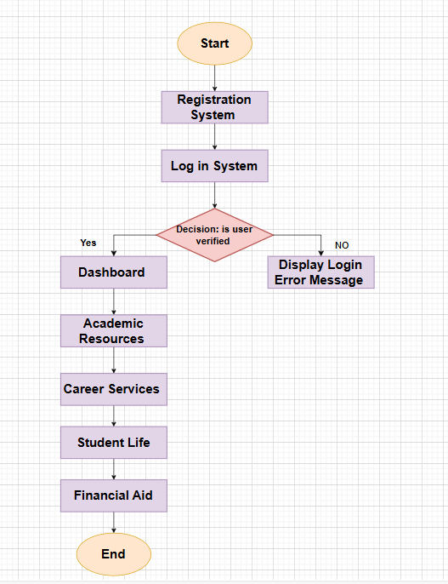**Hosting:**  
The system is **hosted on InfinityFree**, a free web hosting service, allowing the application to be publicly accessed online for testing and deployment.

**Sustainable Development Goal (SDG)**

**SDG 4 – Quality Education**

Ensure inclusive and equitable quality education and promote lifelong learning opportunities for all.

**SDG 8 – Decent Work and Economic Growth**

Support opportunities for internships and part-time jobs that contribute to productive employment and youth development.

**SDG 10 – Reduced Inequalities**

Provide equal access to educational resources and support for students with language barriers or disabilities.

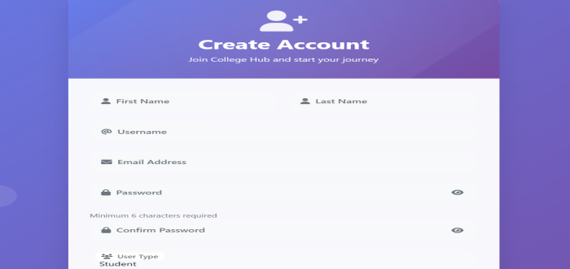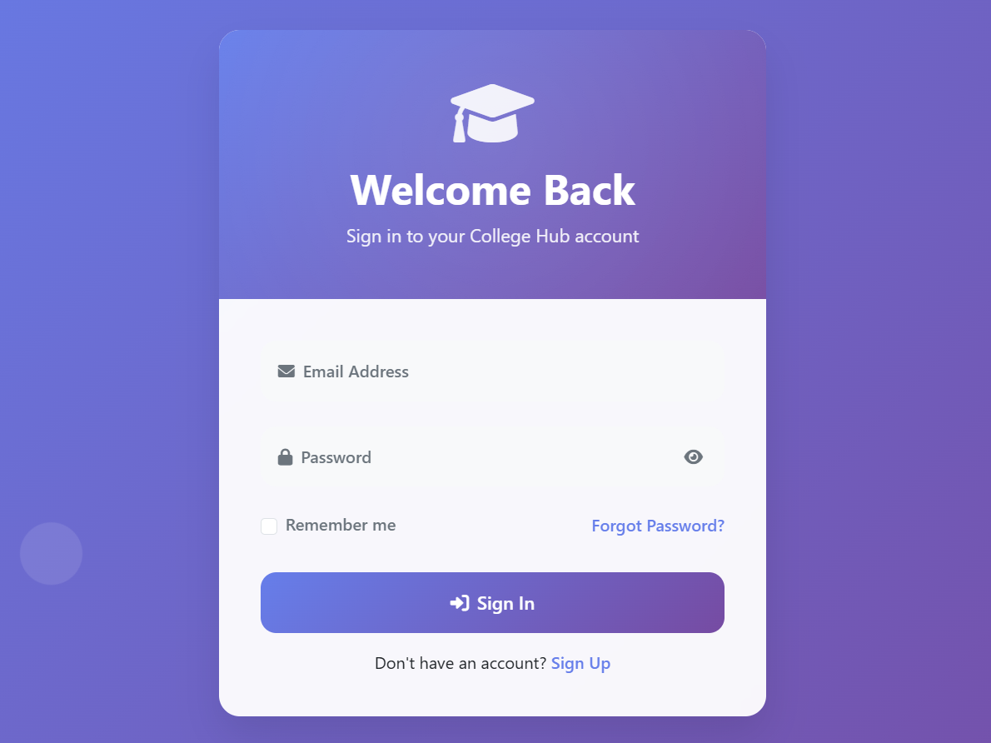**DESIGN WIREFRAME**

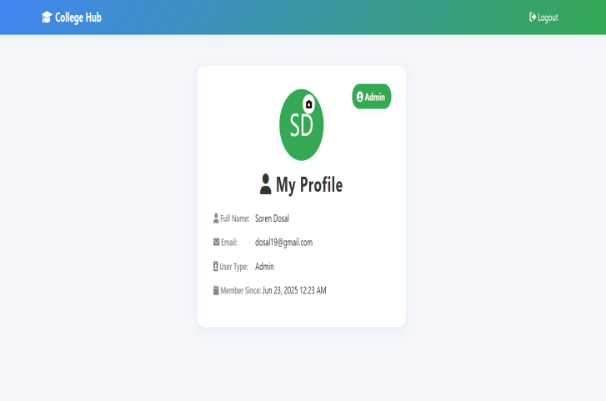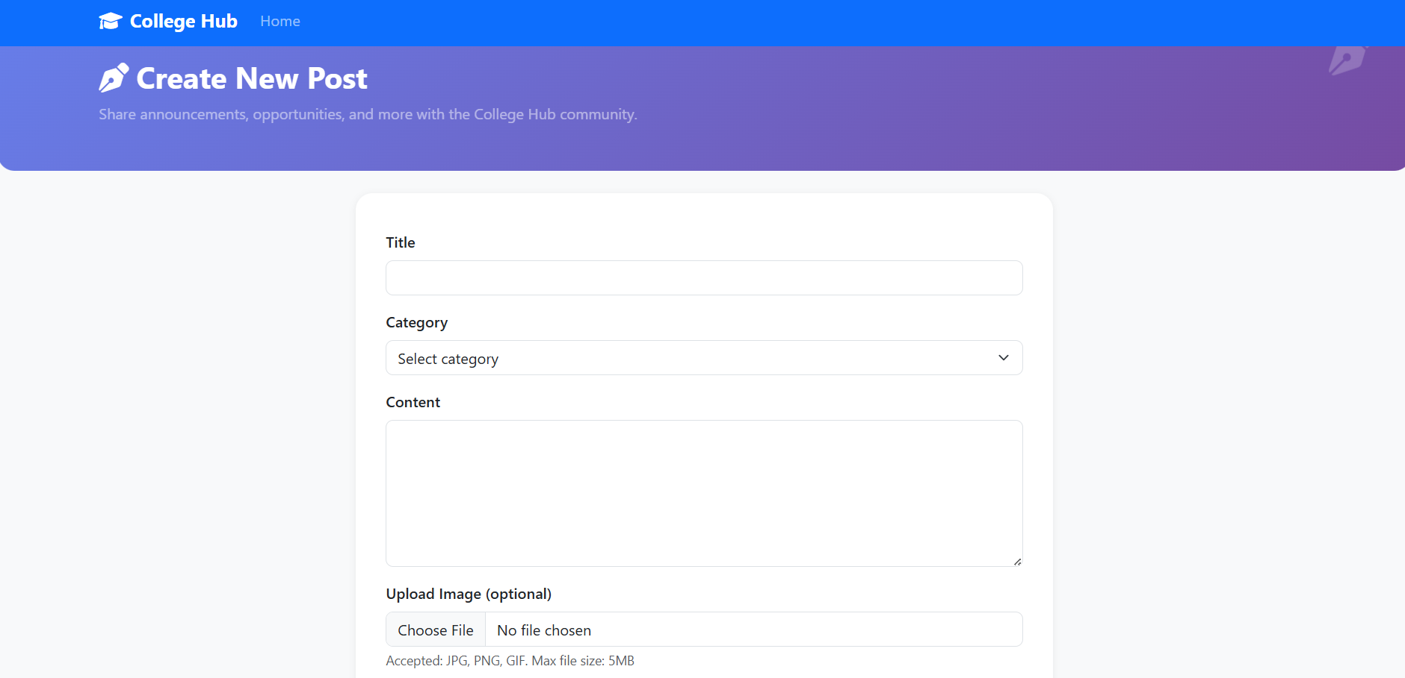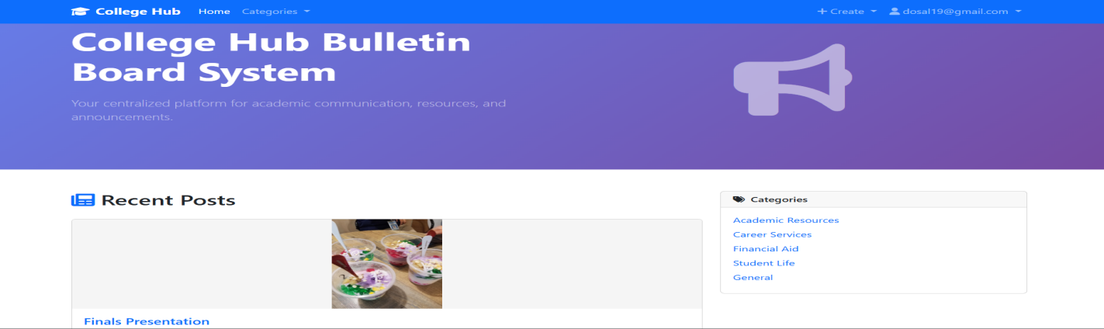**Screenshot 2025-06-24 233346**

**College Hub Bulletin Board System**

**Submitted By**:

ABAIGAR, MYREN GRACE D.

DOSAL, SOREN A.

GERONDA , MARIEL B.

MACALE, JESECA

**Submitted To:**

MR. SYRON DAVE ALINSO-OT

